ANNEX I: TERMS OF REFERENCE
1. BACKGROUND INFORMATION 2
1.1. Partner country 2
1.2. Contracting authority 2
1.3. Country background 2
2. OBJECTIVE, PURPOSE & EXPECTED RESULTS 3
2.1. Overall objective 3
2.2. Purpose 3
2.3. Results to be achieved by the contractor 3
3. ASSUMPTIONS & RISKS 4
3.1. Assumptions underlying the project 4
3.2. Risks 4
4. SCOPE OF THE WORK 4
4.1. General 4
4.2. Specific work 4
4.3. Project management 5
5. LOGISTICS AND TIMING 5
5.1. Location 5
5.2. Start date & period of implementation of tasks 5
6. REQUIREMENTS 6
6.1. Staff 6
6.2. Office accommodation 6
6.3. Facilities to be provided by the contractor 6
6.4. Equipment 6
7. REPORTS 7
7.1. Reporting requirements 7
7.2. Submission and approval of reports 7
8. MONITORING AND EVALUATION 7
8.1. Definition of indicators 7
8.2. Special requirement 7

BACKGROUND INFORMATION

Partner country
Republic of North Macedonia

Contracting authority
PUBLIC ENTERPRISE FOR MANAGING AND PROTECTION FF THE MULTIPURPOSE AREA - JASEN

Country background
Republic of North Macedonia is a country in Southeast Europe. It gained independence in 1991 as one of the successor states of Yugoslavia. North Macedonia is a landlocked with total area of 25,713 km2. It lies between latitudes 40° and 43° N, and mostly between longitudes 20° and 23° E (a small area lies east of 23°). North Macedonia has some 748 km of boundaries, shared with Serbia (62 km) to the north, Kosovo (159) to the northwest, Bulgaria (148 km) to the east, Greece (228 km) to the south, and Albania (151 km) to the west. It constitutes approximately the northern third of the larger geographical region of Macedonia. Skopje, the capital and largest city, is home to a quarter of the country's 2.08 million population. The majority of the residents are ethnic Macedonians, a South Slavic people. Albanians form a significant minority at around 25%, followed by Turks, Romani, Serbs, Bosniaks, and Aromanians.
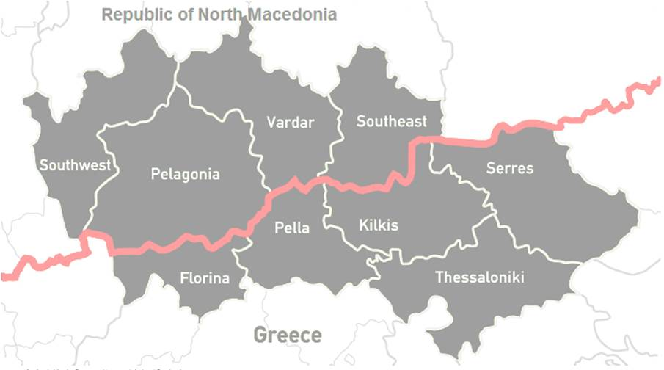
The Project sol-na will be implemented in the cross-border with Greece, in accordance with the EU Interreg CBC Programme “Greece – Republic of North Macedonia 2014-2020”.
Activities in the assignments which are described in these Terms of References, should reflect target area of sol-na project.

OBJECTIVE, PURPOSE & EXPECTED RESULTS

Overall objective
The main objective of the project (Ob1) is to implement a series of actions that will offer nature-based solutions for the prevention of natural disasters (wildfires and floods) in the cross border area and will mitigate their consequences when they take place. This double objective form two distinct axes/sub-objectives acting as two parallel layers; (1) Prevention of natural disasters in the cross border area and (2) Regeneration of the cross border ecosystem after forest fires for flood prevention.
In the 1st layer, new technologies will be used to record/study the natural behaviour of the cross border area in order targeted measures for prevention to be proposed with the minimum environmental footprint. Taking into account their impact in human population, Thessaloniki, Pella and JASEN were selected as study areas.
The 2nd layer is a network of activities that aknowledges the connection between fires and floods and focuses on the quick regeneration of the natural environment of the cross border area after fires; this way, floods caused by damaged ecosystems will be prevented.
Other objectives are:
• Ob2; To promote interventions with nature-based character as a environmental friendly way of acting for the public benefit
• Ob3; To support the civil protection authorities in the development of their civil protection plans
• Ob4; To apply innovative high-edged technology in the field of civil protection in the cross border area
• Ob5; To protect the natural ecosystem of the cross border area by offering new knowledge for its flora species
• Ob6; To improve the awareness of the local population in measures of civil protection
• Ob7; To promote the cross border approach as a solution for the challenges of the natural disasters.

Purpose
The purpose of this contract are as follows:
- Management of the project sol-na (communication, preparation of analyses, organization and participation on the events, etc.)
- Realization of procurement procedures.
- Preparation of progress reports & 1 final report
- Preparation of table of expenditures FLC (First Level Controls) in the MIS system of the Interreg IPA Programme “Greece – Republic of North Macedonia 2014-2020”.

Results to be achieved by the contractor
- Published procurement procedures, evaluated and contract with best tenderers concluded
- Prepared at least 3 project progress reports + one final report submitted to the lead partner
- Tables of expenditures for five FLCs of the sol-na project reviewed in the MIS system (expected are 5 tables)
- Project sol-na successfully completed.

ASSUMPTIONS & RISKS

Assumptions underlying the project
Capacity of the Contractor is adequate to cooperate with the Contracting Authority and follows their guidance.

Risks
Low level of communication and understanding between the Contractor and the Contracting Authority.

SCOPE OF THE WORK

General

Description of the assignment
Assignment is composed of:
- Daily management of the project sol-na (communication, preparation of analyses, organization and participation on the events, etc.)
- Preparation and realization of tenders: preparation of tender documents participation as secretary in evaluation committees, preparation reports of evaluation, validating contract to be signed.
- Preparing at least three project progress reports and one final report.
- Preparing five table of expenditures in the MIS system of the Interreg IPA Programme “Greece – Republic of North Macedonia 2014-2020”,

Geographical area to be covered
All statistical regions in North Macedonia which are part of the EU Interreg CBC Programme “Greece – Republic of North Macedonia 2014-2020”, i.e. regions Southwest, Pelagonia, Vardar and Southeast.

Target groups
Contracting authority of sol-na Project

Specific work
Daily management of the project sol-na
Preparation of communication with Joint Secretariat (JS) according to instructions of the Contracting Authority, preparing all necessary analyses required by the JS and the lead partner, organization and participation of the events of the project sol-na according instructions of the Contracting Authority, communication with the sub-contractors according instructions of the Contracting Authority, and other tasks what will arise during project implementation and which will be delegated by the Contracting Authority.

Preparation and realization of tenders
Preparation of tender documents and publishing a call. Participation as a secretary in the evaluation committee. Preparation of evaluation report. Validation of the contract for signing with the best tenderer.
Tenders should be prepared according to IPA Procurement Manual http://www.ipa-cbc-programme.eu/gallery/Files/Library/Annex-7_1_b1_4_IPA-Rrocurement-Manual_11_2018_v1_3.docx and PRAG Procedures of the European Union PRAG - European Commission - DG International Cooperation and Development (europa.eu)
Tenders should be prepared in accordance with the project STPP file, which will be delivered after signing of the contract.
Project progress reports and one final report.
- Prepare first progress report, January 2023 for the sol-na project.
- Prepare second progress report, July 2023 for the sol-na project.
- Prepare third progress report, December 2023 for the sol-na project.
- Prepare final report.

Progress reports and final report should be prepared according relevant guidelines posted here Documents for Project implementation (ipa-cbc-programme.eu)
FLC Reports
- Preparation of five Table of Expenditure for FLC (First Level Control) in the MIS System of the Interreg IPA Programme “Greece – Republic of North Macedonia” according guidelines posted here Documents for Project implementation (ipa-cbc-programme.eu)

Project management

Responsible body
Director / responsible person at PUBLIC ENTERPRISE FOR MANAGING AND PROTECTION FF THE MULTIPURPOSE AREA - JASEN

Management structure
N/A

Facilities to be provided by the contracting authority and/or other parties
N/A

LOGISTICS AND TIMING

Location
Skopje, Republic of North Macedonia

Start date & period of implementation of tasks
The intended start date is 21/11/2022 and the period of implementation of the contract will be till the end of the project sol-na.

REQUIREMENTS

Staff
Note that civil servants and other staff of the public administration of the partner country, or of international/regional organisations based in the country, shall only be approved to work as experts if well justified. The justification should be submitted with the tender and shall include information on the added value the expert will bring as well as proof that the expert is seconded or on personal leave.

Key experts
Key expert: Project manager
Qualifications and skills
Higher Education (Bachelor, Master or PhD). In the absence of formal education at least 10 years’ experience in work with EU funded projects, or projects funded by other international donors.
General professional experience
Participation as manager, financial manager, administrator, procurement expert or similar in at least 4 (preferred 5) projects funded by the EU.
Specific professional experience
At least 3 (preferred 5) successfully realized tenders (at least according singe tender procedure) for the project(s) funded by Interreg IPA Programme Greece – Republic of North Macedonia 2014-2020.
At least 3 (preferred 5) successfully submitted Project Progress Reports for the project(s) funded by Interreg IPA Programme Greece – Republic of North Macedonia 2014-2020.
At least 3 (preferred 5) successfully submitted Table of Expenditures for FLC in MIS system for the project(s) funded by Interreg IPA Programme Greece – Republic of North Macedonia 2014-2020.

Office accommodation
Office accommodation for the expert working on the contract is to be provided by the contractor.

Facilities to be provided by the contractor
N/A

Equipment
No equipment is to be purchased on behalf of the contracting authority as part of this service contract or transferred to the contracting authority at the end of this contract.

REPORTS

Reporting requirements
The contractor will submit the following reports in English in electronic format:
- Tender dossier, evaluation report and contract for every tender (four tenders’ dossiers and reports)
- Project progress reports and final submitted to the lead partner (four project progress reports and one final report)
- Table of Expenditure submitted in the MIS System (expected are 5 tables of expenditure)
- All other reports, analyses and communication about the project.

Submission and approval of reports
The reports referred to above must be submitted to the contact person PUBLIC ENTERPRISE FOR MANAGING AND PROTECTION FF THE MULTIPURPOSE AREA - JASEN identified in the contract. The contact person is responsible for approving the reports.

MONITORING AND EVALUATION

Definition of indicators
- For tenders: procurement procedures are approved by the FLC controller and responsible project officer in the Joint Secretariat of the Interreg IPA Programme Greece – Republic of North Macedonia 2014-2020.
- For project progress reports and final report: they are approved by the responsible project officer in the Joint Secretariat of the Interreg IPA Programme Greece – Republic of North Macedonia 2014-2020.
- For Tables of Expenditures: they are approved by the FLC controller and responsible project officer in the Joint Secretariat of the Interreg IPA Programme Greece – Republic of North Macedonia 2014-2020.
- For other managerial tasks: communication, reports, etc. are approved by the

Special requirement
N/A

